|  |
| --- |
|  |
| Labs of Rynth |
| Iteration 4  GitHub: <https://github.com/micle546/LabsOfRynth>  Issues and Tasks: <https://github.com/users/micle546/projects/9> |

|  |
| --- |
| Mike Eubank (meubank);Chris Coggins (ccoggins)  11-29-2022 |

## Project Status

We’re definitely behind, as we have both been busy with other classes, but we’re making progress again. We’ve implemented a working player interaction script, and have started on the UI and are progressing on the core game mechanics.

Next iteration, we are planning to finish out the player interactions, finalizing the mechanics, and complete the game.

## Project tasks

Please see the following links for an up-to-date status of the current project

Project tasks categories: <https://github.com/users/micle546/projects/9/>

Iteration Overview: <https://github.com/users/micle546/projects/9/views/4/>

## Project visuals

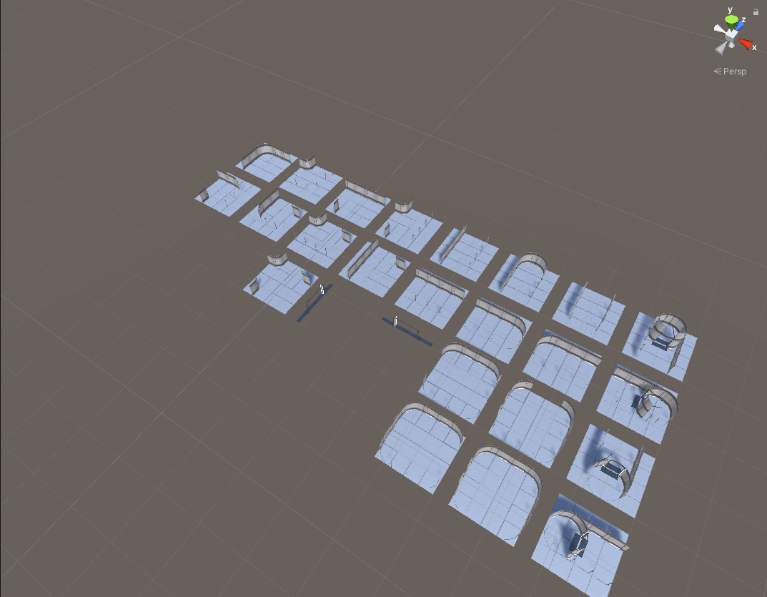

Figure – Map building blocks prepped for generation algorithim

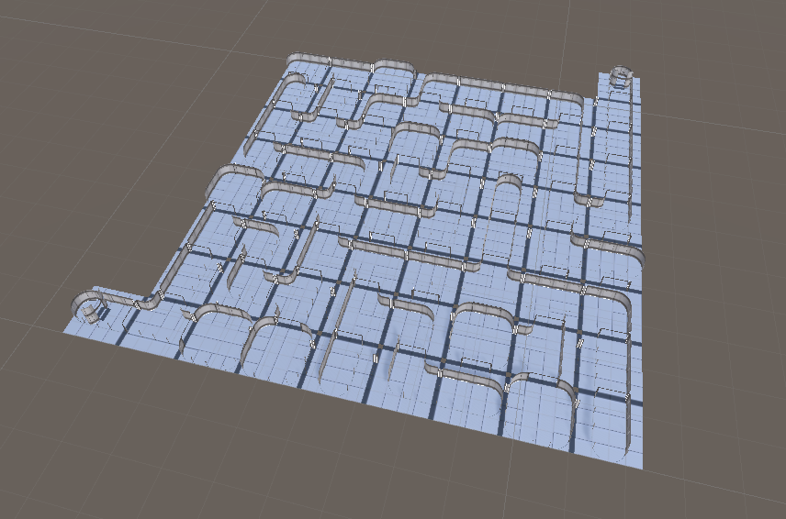

Figure – Test map generation

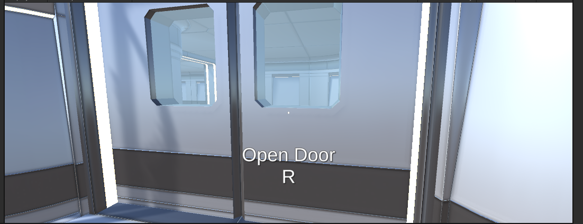

Figure – Door Interaction setup, see video for animation

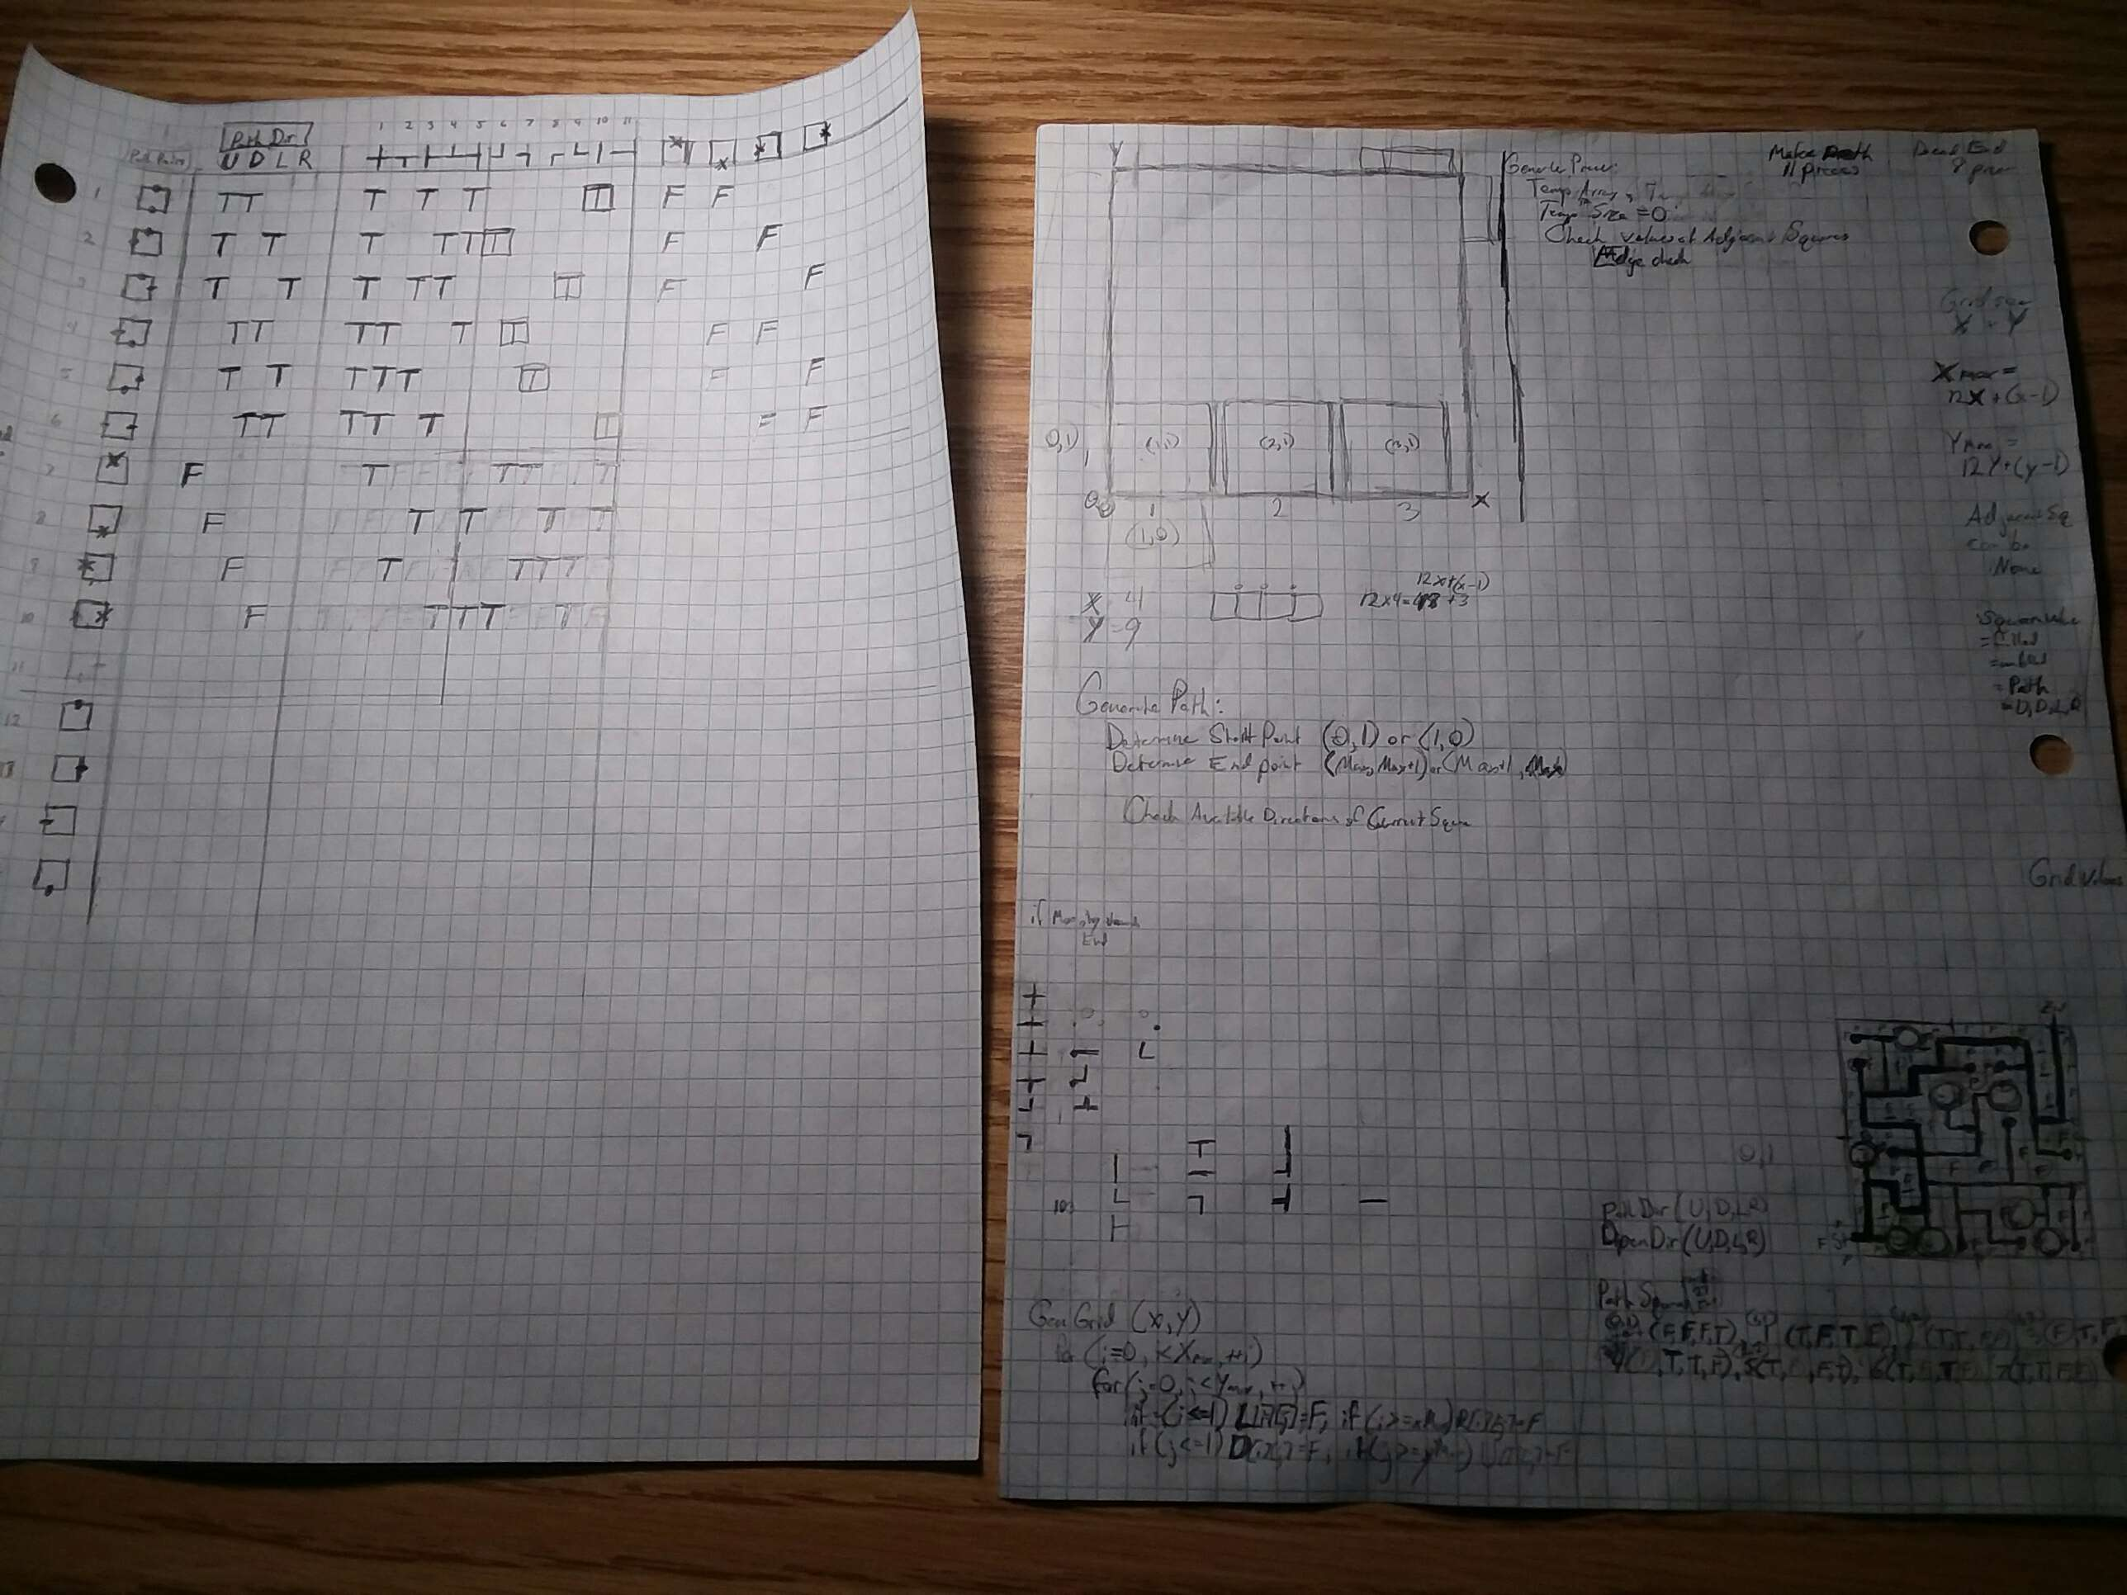

Figure - Maze generation logic concepts